**Pizza Sale SQL Queries**

**KPI’s (Key Performance Indicator)**

1. Total Revenues: -

select SUM(total_price) AS "Total Revenue" from pizza_sales

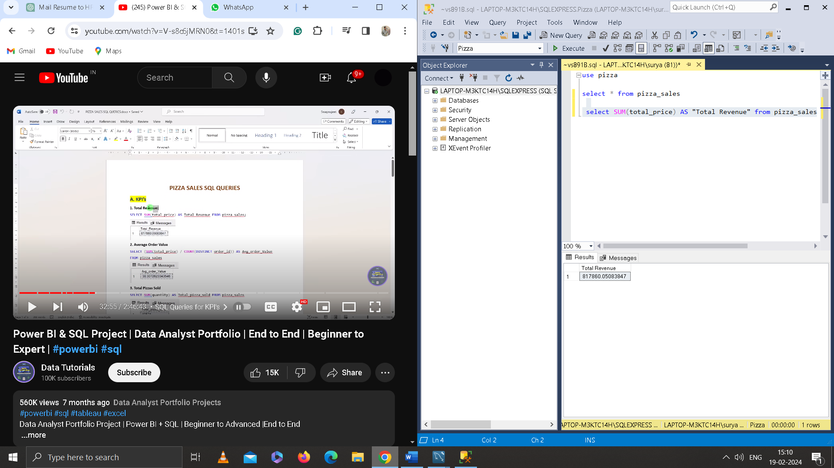

1. Average Order Value: -

select SUM(total_price) / COUNT(DISTINCT order_id) as "Average Order Value" from pizza_sales

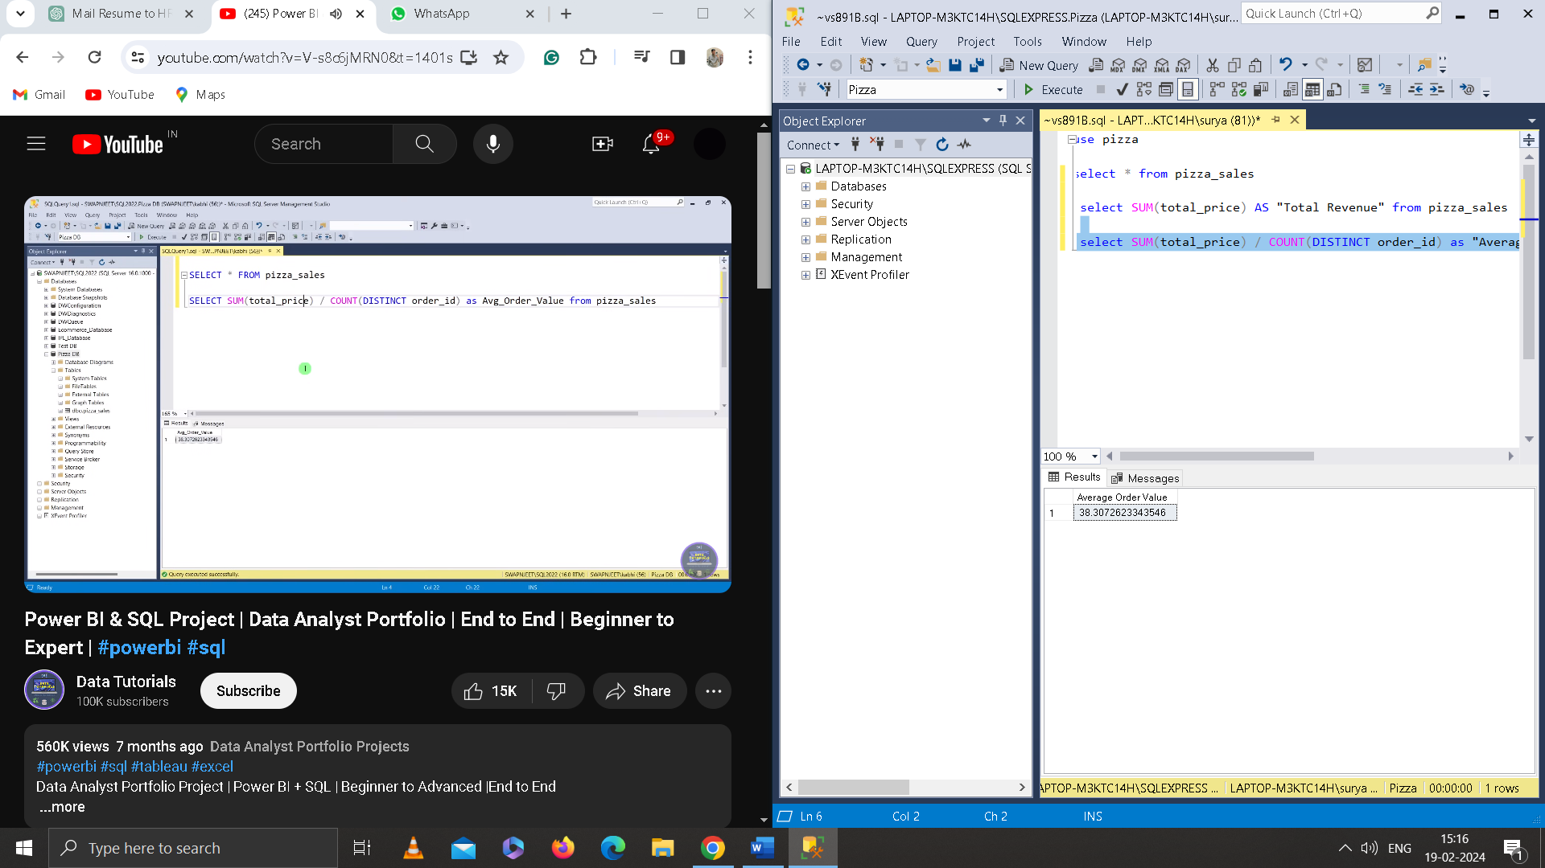

1. Total Pizza Sold: -

select SUM(Quantity) AS "Total Pizza Sold" from pizza_Sales

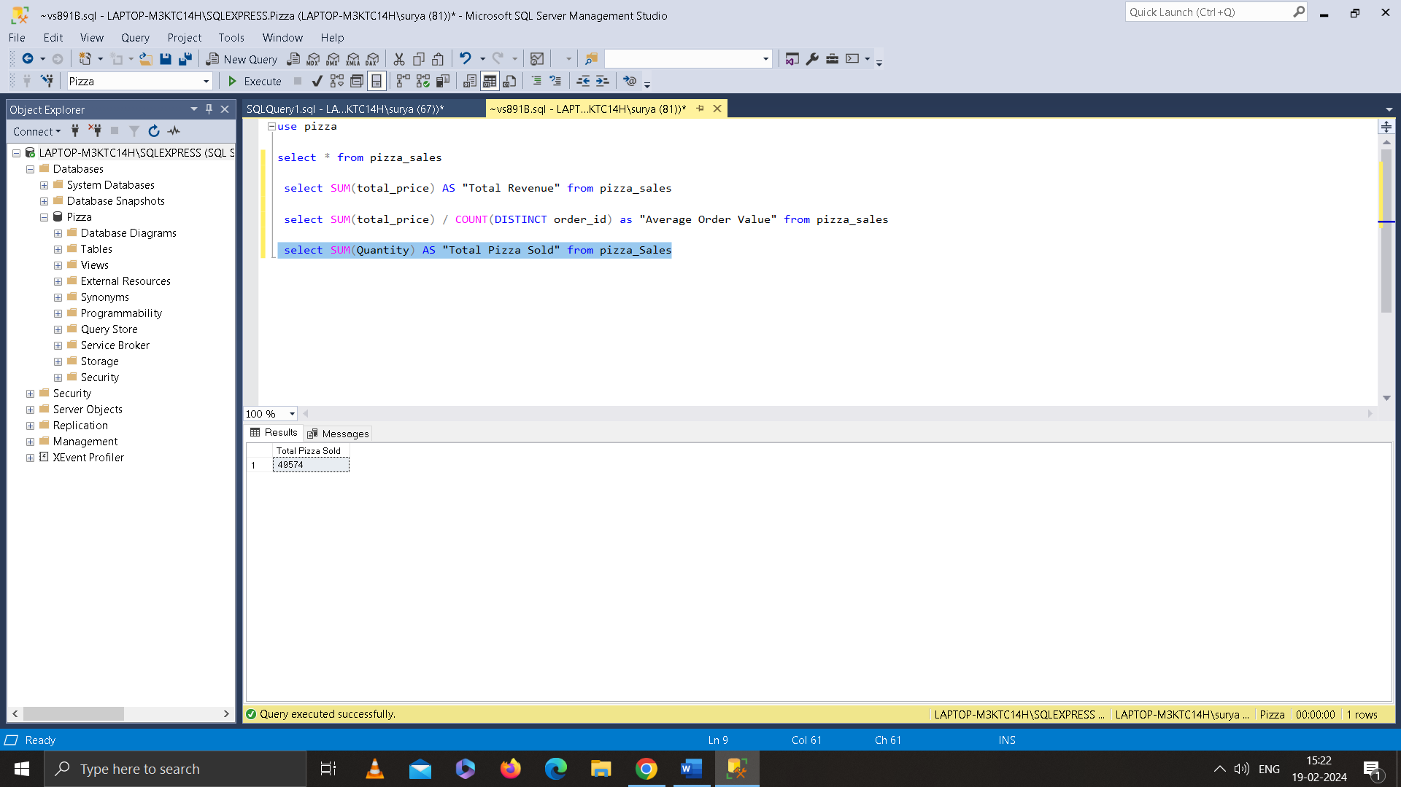

1. Total Orders: -

select Count(DISTINCT order_id) as "Total Orders" from pizza_sales

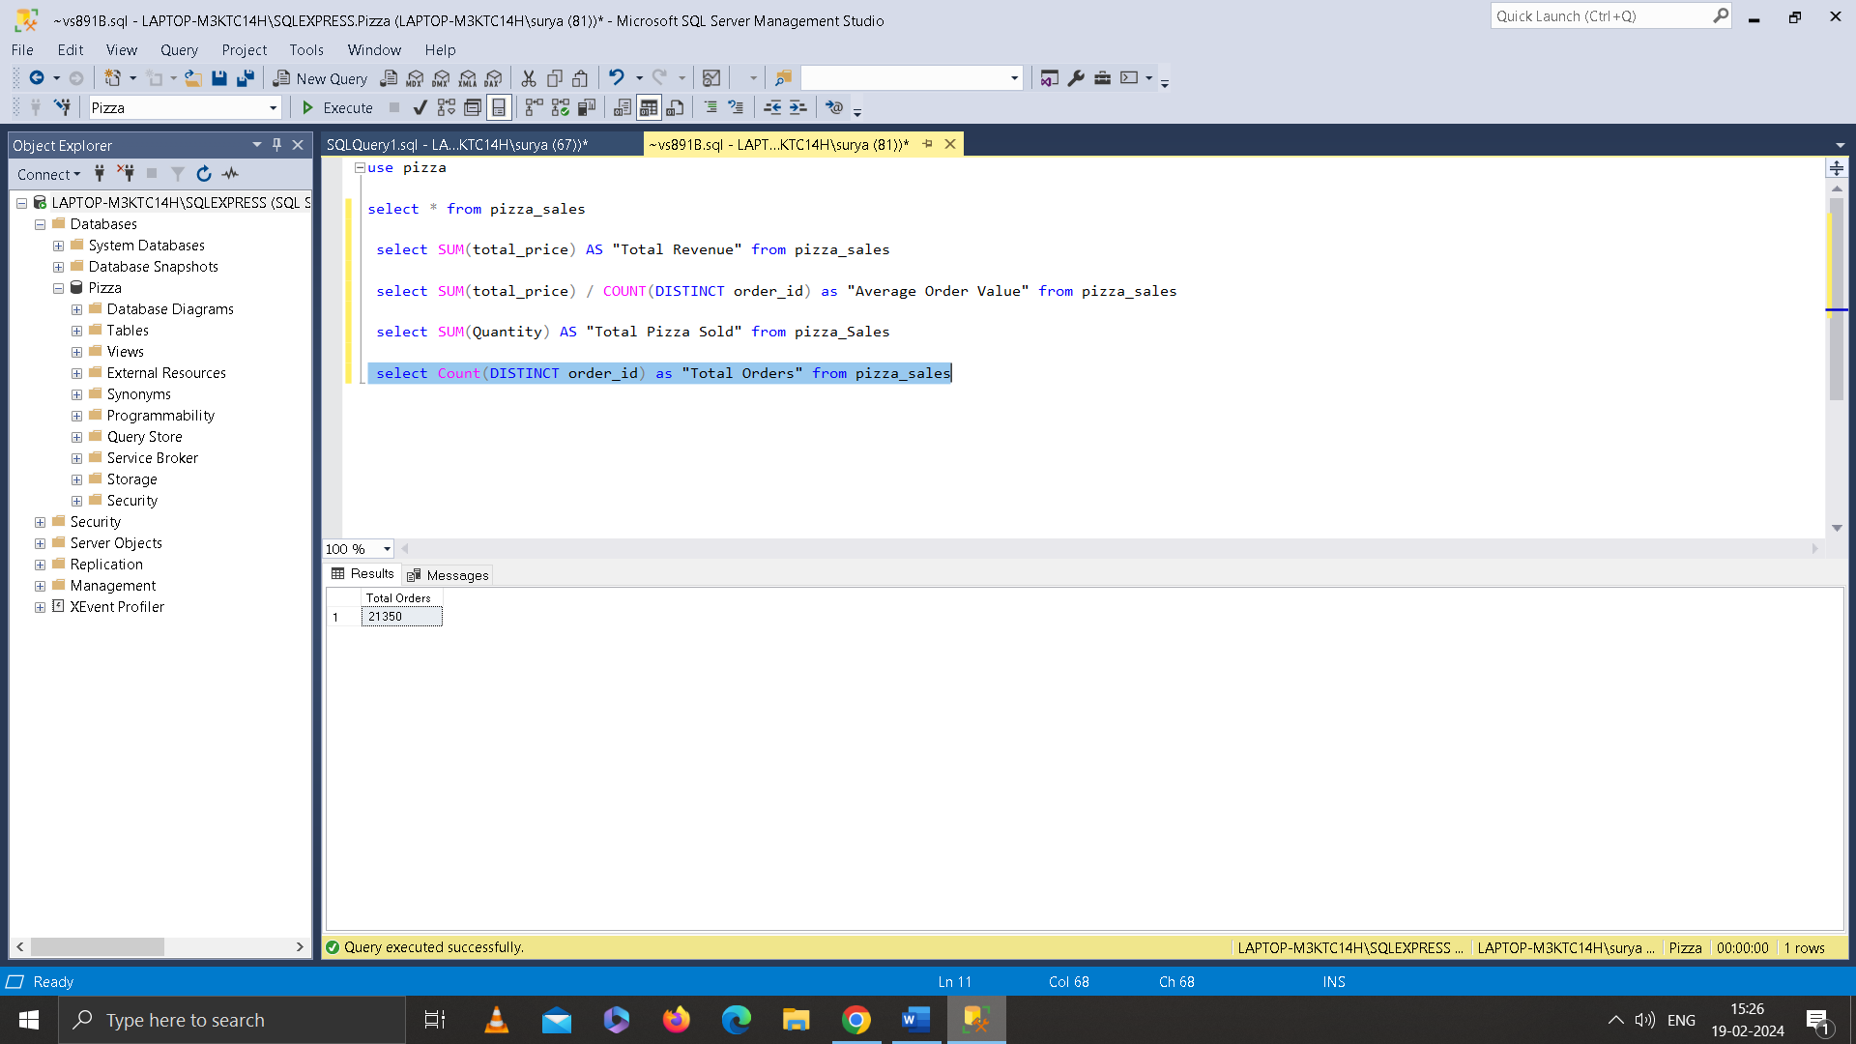

1. Average Pizzas Per Order: -

select SUM(Quantity) / Count(DISTINCT order_id) as "Average Pizza Per Orders" from pizza_sales

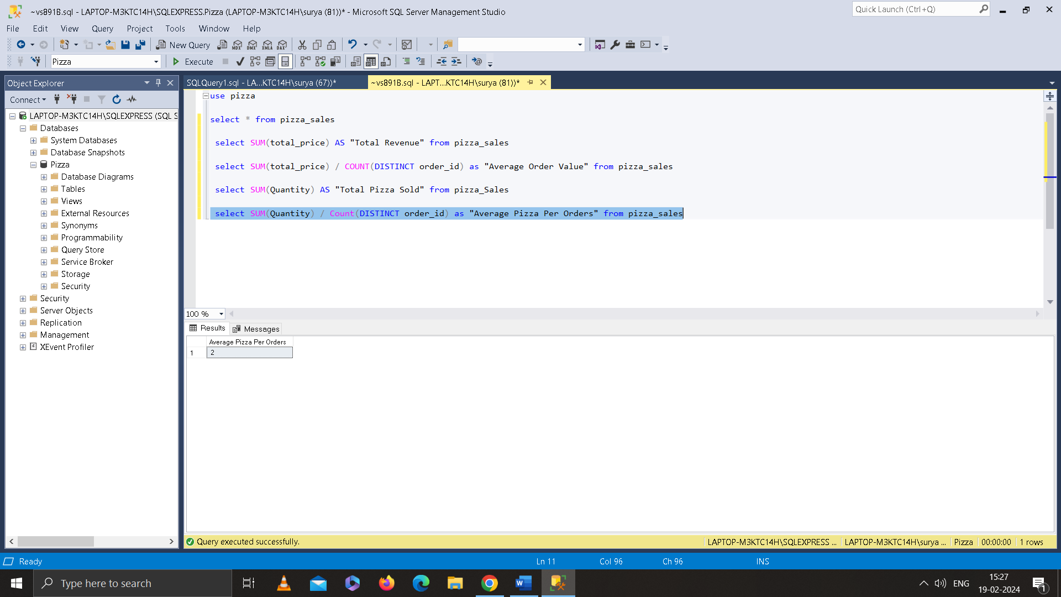

1. To Get the Value is Decimal use CAST() Function.

select CAST(CAST(SUM(Quantity) AS Decimal(10,2)) / CAST(Count(DISTINCT order_id) AS DECIMAL (10,2)) AS DECIMAL (10,2)) as "Average Pizza Per Orders" from pizza_sales

select CAST(SUM(Quantity) AS Decimal(10,2)) / CAST(Count(DISTINCT order_id) AS DECIMAL (10,2)) as "Average Pizza Per Orders" from pizza_sales

The Cast the SQL CAST function converts the data type of an expression to the specified data type.

**Problem Statement**

Chart Requirements: -

1. Daily Trends For Total Order: -

select DATENAME(DW, order_Date) AS "Order Day" , COUNT(DISTINCT order_id) as "Total Order" from pizza_sales Group by DATENAME(DW, order_Date)

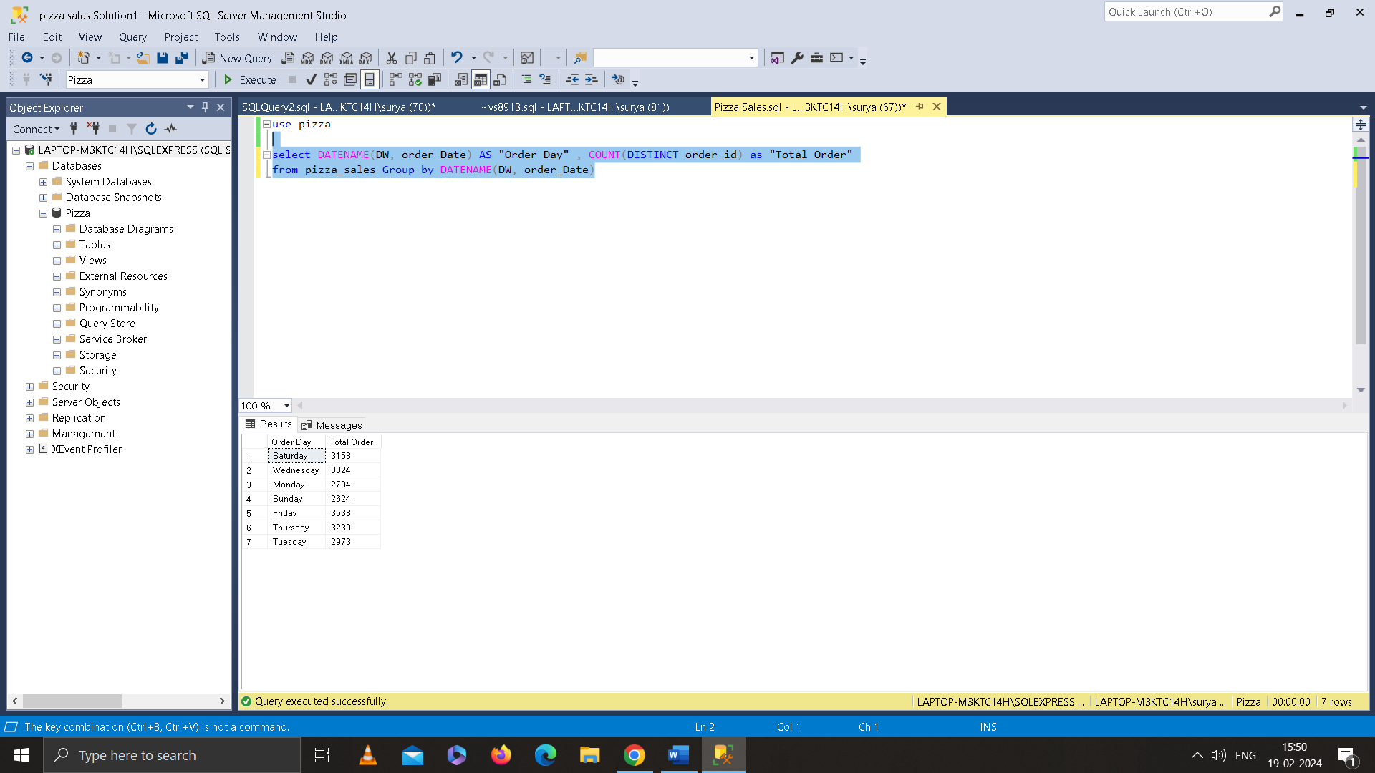

1. Hourly Trend for Total Orders: -
2. Percentage of Sales by Pizza category: -

select pizza_category, sum(total_price),sum(total_price) *100 / (select sum(total_price) from pizza_sales where MONTH(order_date) = 1) as PCT

from Pizza_sales where MONTH(order_date) = 1 group by pizza_category

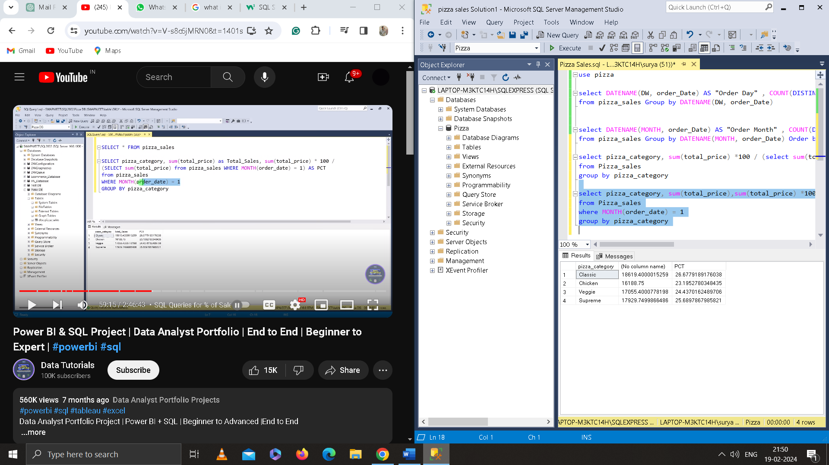

1. Percentage of Sales by Pizza Size: -

select pizza_size, sum(total_price) AS total_price,sum(total_price) *100 (select sum(total_price) from pizza_sales) as PCT

from Pizza_sales group by pizza_size

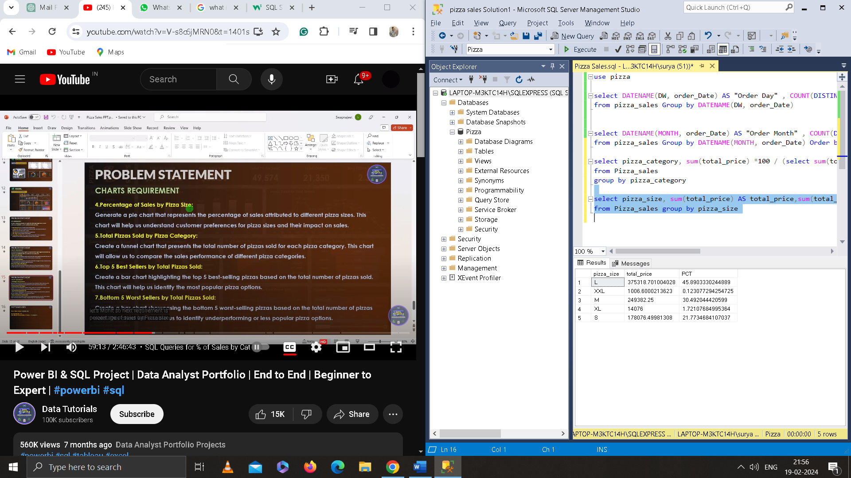

1. Total pizza sold by Pizza Category: -

select pizza_category, sum(total_price) *100 / (select sum(total_price) from pizza_sales) as PCT from Pizza_sales

group by pizza_category

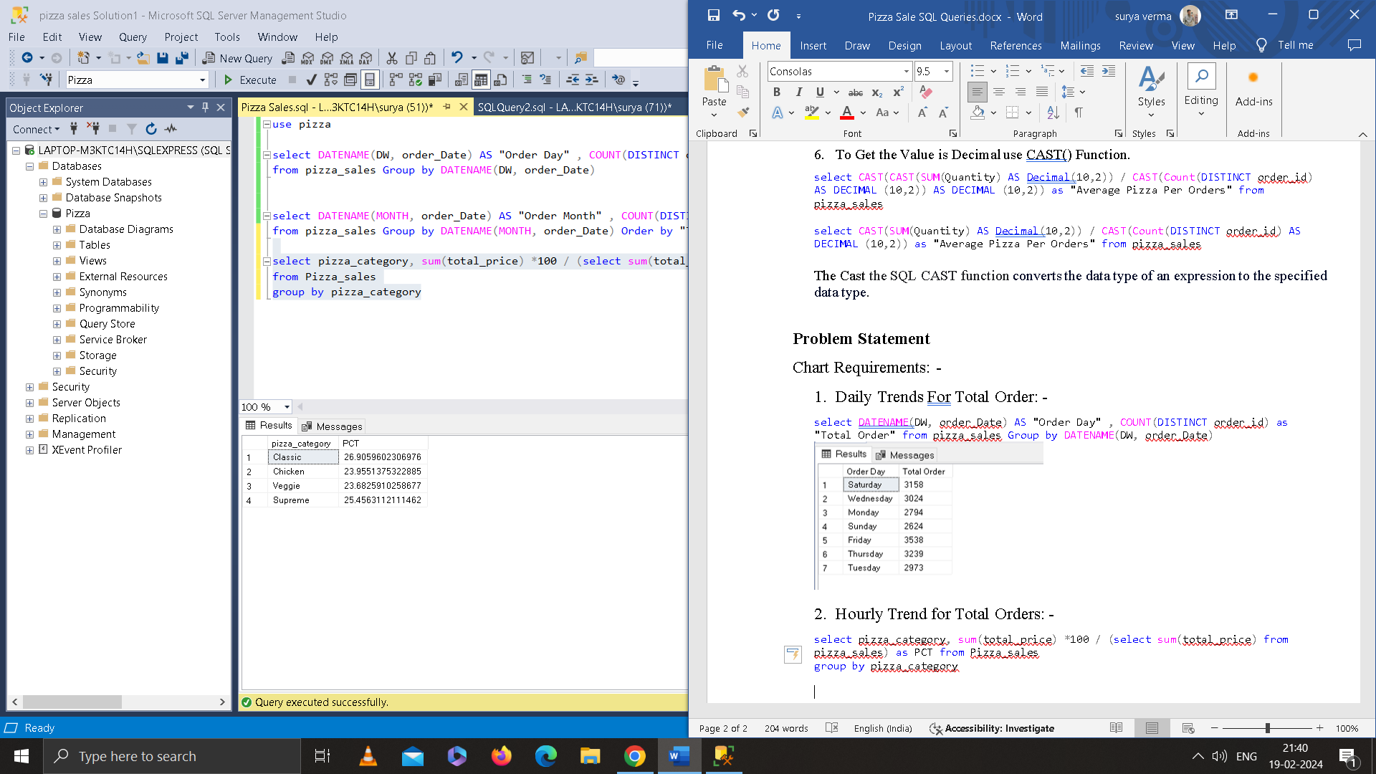

1. Top 5 best seller by Total Pizza Sold: -

select TOP 5 pizza_name , sum(total_price) as Total_Revenue from pizza_sales

group by pizza_name

order by total_revenue desc

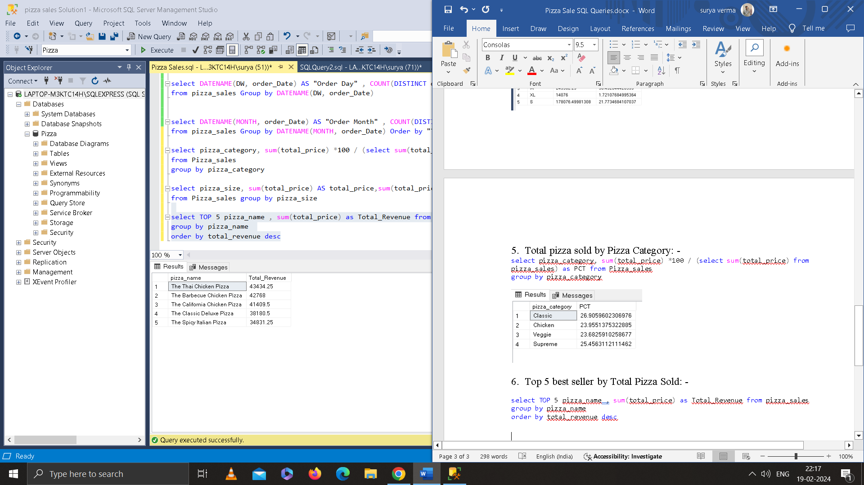

1. Bottom 5 Worst Sellers by Total Pizzas Sold: -

select TOP 5 pizza_name , sum(total_price) as Total_Revenue from pizza_sales

group by pizza_name

order by total_revenue asc

